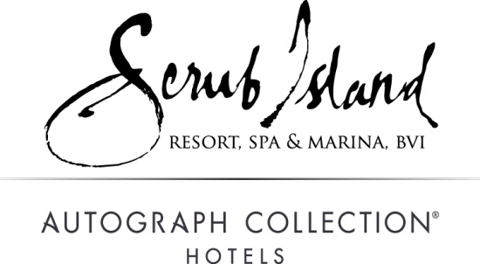

Contacts: Sarah Weaver, Account Executive Norwood Smith, VP of Sales & Marketing
Hayworth Public Relations Mainsail Lodging & Development
386-256-2583 813-243-2634
sarah@hayworthpr.com nsmith@mainsailhotels.com

SCRUB ISLAND RESORT’S MARINA SETS STANDARD FOR SAILORS

BRITISH VIRGIN ISLANDS – Located in the “sailing capital of the Caribbean,” the serene private island haven of Scrub Island Resort is home to the newest marina in the British Virgin Islands (BVI). Scrub Island Resort’s Marina offers 55 slips for lease or transient docking, including five accommodating mega yachts up to 160 feet. Sailing and boating enthusiasts alike can appreciate the region’s fair weather, gentle trade winds and easy access to more than 60 additional nearby islands. Virgin Gorda, Jost Van Dyke, St. Thomas, St. Kitts and Nevis are among the many island-hopping destinations within a day’s sail of Scrub Island’s Marina.
“The marina’s popularity continues to exceed expectations as boaters from around the world visiting the BVI take notice of our personalized service and unrivaled location,” explains Federico Ciampi, resort manager at Scrub Island Resort, Spa & Marina.
Scrub Island’s Marina is the departure point for most of the water-oriented activities available at the resort. Yachts and watercraft of all sizes are available for group and private charters from sightseeing to deep sea fishing. Here, visitors can explore the breathtaking sea life surrounding the island with daily group snorkel tours, dive trips, eco-explorer tours and private dive, snorkel and sightseeing charters. The shallows surrounding Scrub Island, as well as many nearby coves, bays, reefs and inlets, are ideal for snorkelers and divers. Dive BVI is located on-site offering expert instruction including SSI and PADI certification.
Scrub Island is also the closest destination to the North Drop, known as the “honey spot” for tuna and world-record blue marlin fishing. Guests can book full or half-day fishing excursions complete with boat, guide and equipment. Speed boat adventures, island hopping and sailing cruises can all also be arranged.
The marina is open daily with fresh water, electric hook-up, trash service, ice and other full-service offerings in a scenic setting. The Marina Village shops include the Gourmet Market & Café and Antilia Boutique for stocking up on provisions and souvenirs. For an elegant meal before setting sail, Scrub Island Resort is also home to Caravela, a signature fine-dining restaurant featuring Donovan’s Lounge, outdoor seating and a view overlooking the marina.
Daily dockage rates May 1 through December 16 are $2.25 per ft. for boats from 50 – 99 ft. and $2.00 per ft. for those under 50 ft. December 17, 2017 through January 6, 2018 are $6.25 per ft. for boats 50 – 90 ft. and $6 per ft. for those under 50 ft.
Guests’ slip rental will be assessed a 17 percent fee which allows them to enjoy access to all the amenities of the Marina Village including three restaurant outlets, the fine-dining waterfront Caravela, casual poolside dining at Tierra! Tierra! and Gourmet Market & Cafe - a provision store; award-winning Ixora Spa, Dive BVI dive shop, boutique, Antilia, complimentary resort-wide Wi-Fi, use of guest showers, swimming pools, water slide and hot tub, and use of the resort’s scheduled ferry service to and from Trellis Bay.
For more information on the marina at Scrub Island Resort, Spa & Marina or to make a reservation, call toll free U.S. 877-890-7444 or visit scrubisland.com.

# # #

