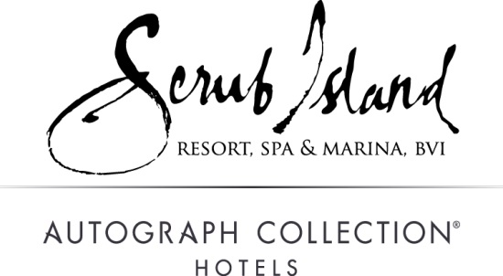

Contacts: Sarah Weaver, Account Executive Norwood Smith, VP of Sales & Marketing
Hayworth Public Relations Mainsail Lodging & Development
386-256-2583 813-243-2634
sarah@hayworthpr.com nsmith@mainsailhotels.com

MEETINGS & INCENTIVES FACT SHEET

THE RESORT: | Scrub Island Resort, Spa & Marina is a distinctive option for corporate and incentive groups. Scrub Island Resort features 17,000 sq. ft. of function space and a collection of inventive locations for events and team building sessions. The private island resort features 52 guest accommodations as well as a collection of two-, three-, four- and six-bedroom villas, Ixora Spa, world-class restaurants, three private beaches, nature trails and a 55-slip marina.
THE DESTINATION: | Scrub Island is located on a serene 230-acre private island one mile from the east end of Tortola. It is 74 miles east of Puerto Rico and 28 miles northeast of St. Thomas and offers ample opportunities to discover and explore the natural beauty of the British Virgin Islands.
MEETING/EVENT SPACE: | Scrub Island offers 2,100 sq. ft. of contemporary air-conditioned meeting space, the most in the British Virgin Islands, along with 15,000 sq. ft. of outdoor function space.  The ballroom, featuring natural stone flooring and elegant millwork, accommodates up to 120 people and can be divided into three spaces named Nina, Pinta and Santa Maria. A full menu of audio-visual equipment is available for groups and meetings. The ballroom opens to the resort’s Grand Patio overlooking the marina and Caribbean Sea.  The Candle Room, a private space that can accommodate up to 20 people, and is located in Caravela, the resort’s signature restaurant. Enveloped by a climate controlled wine cabinet, the room features rich red leather furnishings, hardwood floors and overlooks the surrounding waters.  The pool at North Beach is also a popular locale for on-island functions. Its One Shoe Beach Bar & Grill has food and beverage capabilities available for group functions and is a top choice for farewell events.  Governor’s Point is located on a rugged cliff, offerings stunning views of the Atlantic Ocean. It can function as a venue for cocktails and live music.
THE PRIVATE ISLAND EXPERIENCE: | The island’s private hillside villas measure more than 6,000 square feet and offer expansive views of the Caribbean Sea. They feature large balconies with private pools and kitchens equipped with SubZero, Wolf and Viking appliances that can be utilized by the resort’s talented culinary team.  Scrub Island Resort can also arrange for events to take place at an exclusive property called Wali Nikiti. The home is set on two acres of land spilling down to the Atlantic Ocean. An exclusive venue, it is cocooned in foliage from Broom Palms and Turpentine trees, the open-air home features a thatch roof making the most of the oceanfront environment. Its custom- designed kitchen and living space can be utilized for cooking classes, cocktail parties or five-course dinners.  Groups arrive at the international airport on Tortola and immediately transfer to the property by the resort’s private ferry. Upon arrival, they are greeted by on-site hosts and offered a refreshing rum punch cocktail.  Memorable group team building activities include charter boat excursions from the resort’s private marina including sailing to neighboring islands and an exclusive Caribbean-style “high tea on the sea.” The British Virgin Islands are known for some of the most legendary beachside watering holes, and island-hopping pub crawls can be arranged by resort hosts for groups of all sizes.  Taking advantage of the resort’s proximity to world-renowned fishing grounds including the North Drop; tournaments can be arranged for battling tuna and giant marlin.
Groups & Meetings Contact: | Additionally, preferred tee-times can be set up at the George and Tom Fazio-designed Mahogany Run Golf Course, a challenging par-70 on neighboring St. Thomas. The island also offers excellent duty-free shopping. Transportation to St. Thomas is very convenient via public ferry from Tortola. A private boat or helicopter transfer can also be arranged.  Nancy Williams, Director of Sales  nwilliams@scrubisland.com
MANAGEMENT: | The developer of Scrub Island Resort, Spa & Marina is Mainsail Lodging & Development LLC of Tampa, Fla. In late 2011, the resort became the first Caribbean property for the Autograph Collection, Marriott International’s fastest growing brand.
RESERVATIONS:  WEBSITE: | Toll Free U.S. 877-890-7444  Direct: 813-849-4100  E-mail: reservations@mainsailbvi.com  scrubisland.com
- Scrub Island Resort, Spa & Marina -

